**Name: Mi Gao**

**Tools: Oracle Live SQL**

# Overview of the Assignment:

Oracle, IBM DB2 and other ORDBMS that support standard object-relational features.

**Please submit screenshots demonstrating the execution of your SQL statements, both DDL , DML and the results of the SQL statements.**

# Object-relational DBMS

In this exercise, we will construct and query an *AUTOMOBILE* table by using abstract data types (ADTs), VARRAYs, and nested tables. The syntax is for Oracle.

1. Create a *PERSON_TY* abstract data type which has the following fields -- first_name, last_name, date_of_birth. Assign each field an appropriate data type.

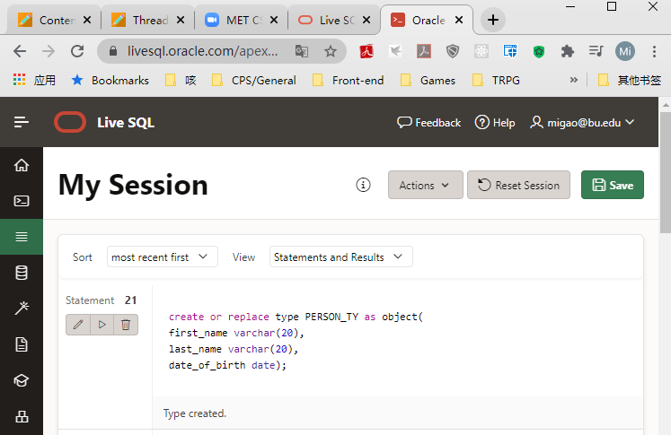

1. Create a *DRIVER_TY* abstract data type which has the following fields -- *PERSON_TY,* Drivers_License_ID, Date Driven. Assign each field an appropriate data type.

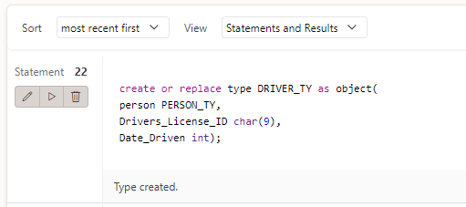

1. Create a *OWNER_TY* abstract data type which has the following fields -- *PERSON_TY, Date_Purchased, Date_Sold.* Assign each field an appropriate data type.

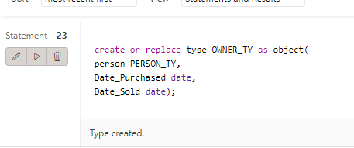

1. Create a *OWNERS_VA* VARRAY of the *OWNER_TY* abstract data type you created in step 2. Define the VARRAY to allow for 3 *OWNER_TY* elements.

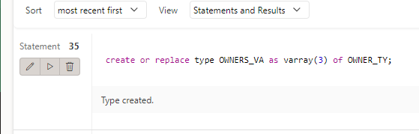

1. Create an *AUTOMOBILE* table which is composed of the following elements:

* A vehicle_identification_number field which is the primary key.
* An OWNER*_VA* VARRAY.
* A nested table named *DRIVERS_NT* which contains the following fields – *DRIVER_TY*. Assign each field an appropriate data type.

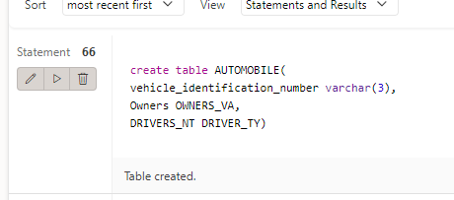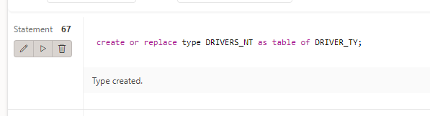

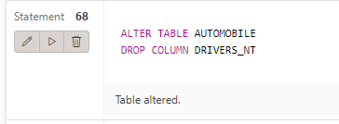

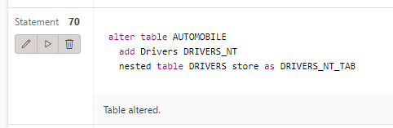

1. Insert the following rows into the *AUTOMOBILE* table:  
   **ROW 1**

* The Vehicle Identification Number is 101.
* The first driver is named "Erin Smalltalk", who was born on 5/23/1965, driver license MA101, date driven 3/1/2018.
* The second driver is named "Joe Smalltalk", who was born on 10/7/1982, driver license MA204, date driven 3/15/2018.
* The only owner is named "Lance Smalltalk", who purchased the automobile 1/29/2016.

**ROW 2**

* The Vehicle Identification Number is 102.
* The first driver is named "Julie Goldstein", who was born on 7/19/1977, driver license MA506, date driven 1/5/2016.
* The second driver is named "Max Lucids", who was born on 2/12/1987, driver license MA706, date driven 3/5/2018.
* The first owner is named "George Stephanopolis", who purchased the automobile 7/15/2014 and sold on 6/17/2016.
* The second owner is named "Max Lucids", who purchased the automobile on 6/18/2016.

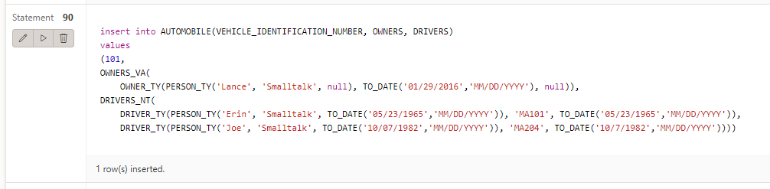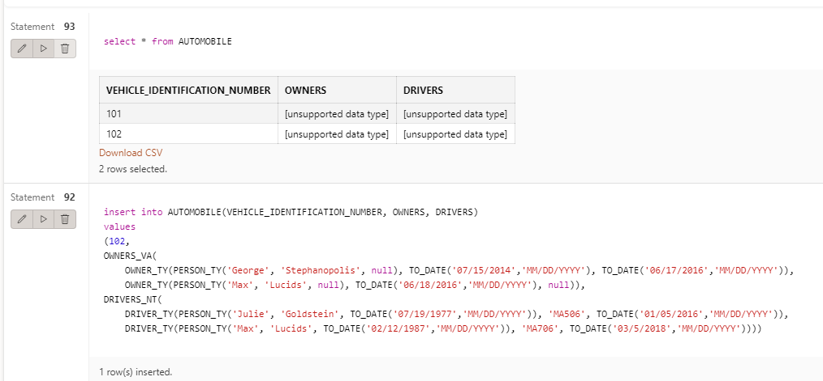

1. Write a query which lists the first and last names of all drivers, along with the vehicle identification number of the car they drive and date driven.

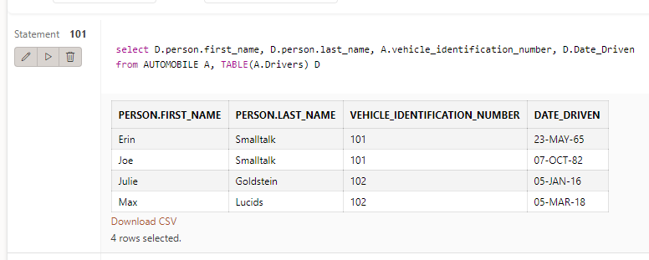

1. Write a query which lists the first and last names of all owners, along with the vehicle identification number of the car, the date of purchase and sale.

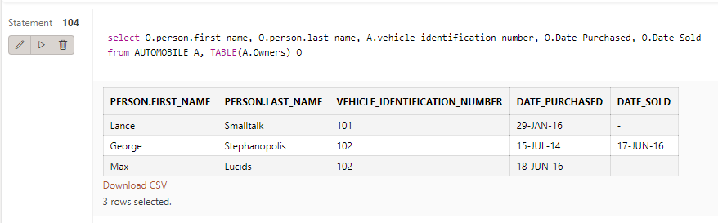

--Codes:

drop type PERSON_TY;

drop type DRIVER_TY;

drop type OWNER_TY;

drop table DRIVERS_NT;

drop table AUTOMOBILE;

create or replace type PERSON_TY as object(

first_name varchar(20),

last_name varchar(20),

date_of_birth date);

create or replace type DRIVER_TY as object(

person PERSON_TY,

Drivers_License_ID char(5),

Date_Driven date);

-----------VARRAY

-- create a new owner data type

create or replace type OWNER_TY as object(

person PERSON_TY,

Date_Purchased date,

Date_Sold date);

-- now create a varray of professors

create or replace type OWNERS_VA as varray(3) of OWNER_TY;

-- create a AUTOMOBILE table

create table AUTOMOBILE(

vehicle_identification_number varchar(3),

Owners OWNERS_VA,

DRIVERS_NT DRIVER_TY);

-- create a nested table called DRIVERS_NT

create or replace type DRIVERS_NT as table of DRIVER_TY;

-- make update

ALTER TABLE AUTOMOBILE

DROP COLUMN DRIVERS_NT;

alter table AUTOMOBILE

add Drivers DRIVERS_NT

nested table DRIVERS store as DRIVERS_NT_TAB;

insert into AUTOMOBILE(VEHICLE_IDENTIFICATION_NUMBER, OWNERS, DRIVERS)

values

(101,

OWNERS_VA(

OWNER_TY(PERSON_TY('Lance', 'Smalltalk', null), TO_DATE('01/29/2016','MM/DD/YYYY'), null)),

DRIVERS_NT(

DRIVER_TY(PERSON_TY('Erin', 'Smalltalk', TO_DATE('05/23/1965','MM/DD/YYYY')), 'MA101', TO_DATE('05/23/1965','MM/DD/YYYY')),

DRIVER_TY(PERSON_TY('Joe', 'Smalltalk', TO_DATE('10/07/1982','MM/DD/YYYY')), 'MA204', TO_DATE('10/7/1982','MM/DD/YYYY'))));

insert into AUTOMOBILE(VEHICLE_IDENTIFICATION_NUMBER, OWNERS, DRIVERS)

values

(102,

OWNERS_VA(

OWNER_TY(PERSON_TY('George', 'Stephanopolis', null), TO_DATE('07/15/2014','MM/DD/YYYY'), TO_DATE('06/17/2016','MM/DD/YYYY')),

OWNER_TY(PERSON_TY('Max', 'Lucids', null), TO_DATE('06/18/2016','MM/DD/YYYY'), null)),

DRIVERS_NT(

DRIVER_TY(PERSON_TY('Julie', 'Goldstein', TO_DATE('07/19/1977','MM/DD/YYYY')), 'MA506', TO_DATE('01/05/2016','MM/DD/YYYY')),

DRIVER_TY(PERSON_TY('Max', 'Lucids', TO_DATE('02/12/1987','MM/DD/YYYY')), 'MA706', TO_DATE('03/5/2018','MM/DD/YYYY'))));

-- TEST

select A.vehicle_identification_number, D.l

from AUTOMOBILE A, Table(A.Drivers) D;

-- query which lists the first and last names of all drivers, along with the vehicle identification number of the car they drive and date driven.

select D.person.first_name, D.person.last_name, A.vehicle_identification_number, D.Date_Driven

from AUTOMOBILE A, TABLE(A.Drivers) D;

-- query which lists the first and last names of all owners, along with the vehicle identification number of the car, the date of purchase and sale.

select O.person.first_name, O.person.last_name, A.vehicle_identification_number, O.Date_Purchased, O.Date_Sold

from AUTOMOBILE A, TABLE(A.Owners) O;

Use the **Ask the Teaching Team Discussion Forum** if you have any questions regarding the how to approach this assignment.

Save your assignment as ***lastnameFirstname_assign6_0.docx*** and submit it in the *Assignments* section of the course.

For help uploading files please refer to the *Technical Support* page in the syllabus.